SENIOR MASTER SERGEANT KEVIN E. “KJ” JOHNSON
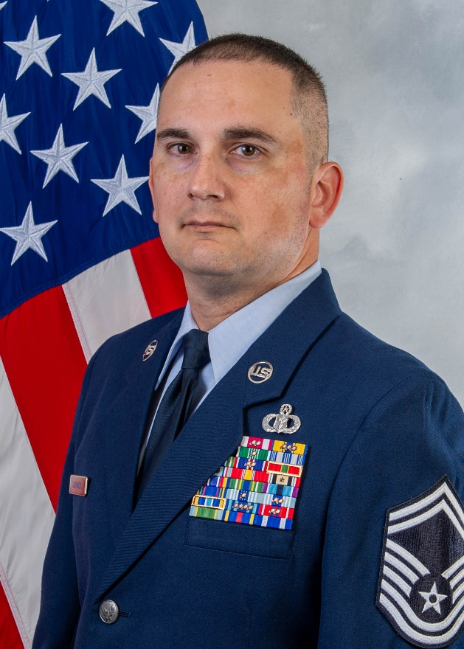
SMSgt Kevin Johnson is the Senior Enlisted Leader for the United States Air Force (USAF) Warrant Officer Training School located at Maxwell Air Force Base (AFB), Alabama. He is the enlisted advisor to the Commandant on all matters relating to the comprehensive management of schoolhouse operations, training, and professional development for 150 candidates annually. He advises and integrates into the development of highly skilled warfighting advisors, prepared to integrate technical and specialized expertise across the spectrum of strategic competition.

SMSgt Johnson was born in Bellevue, Nebraska, and entered the Air Force in August 2004 as a Weather Forecaster Apprentice. He has deployed in support of Operation IRAQI FREEDOM and ATLANTIC RESOLVE, and has extensive experience with Operation NOBLE EAGLE, EPIC FURY, the United Nations Command Military Armistice Commission located in the Republic of Korea, and United States Army Combat Weather capability employment.

Prior to this assignment, SMSgt Johnson served as the Senior Enlisted Leader, 1st Combat Weather Squadron, Joint Base Lewis-McChord, Washington.

EDUCATION
2008 USAF Airman Leadership School, Scott AFB, IL
2014 USAF Smart Operations Green Belt Certification, Joint Base Pearl Harbor-Hickam, HI
2015 USAF Non-Commissioned Officer Academy Course 15 / Intermediate Leadership Experience, Keesler AFB, MS
2016 Senior Enlisted Joint Professional Military Education I
2017 USAF Senior Non-Commissioned Officer Academy Course 14v6
2019 Associate in Meteorology, Community College of the Air Force
2019 USAF Resiliency Training Assistant Course, Osan Air Base, Republic of Korea
2020 Senior Enlisted Joint Professional Military Education II
2022 USAF Senior Non-Commissioned Officer Academy, Maxwell AFB-Gunter Annex, AL
2023 Air University Leadership Development Course, Maxwell AFB, AL
2026 USAF Train, Advise, Coach (AFTAC) Instructor Course, Maxwell AFB, AL

ASSIGNMENTS
- August 2004 – October 2004, Basic Military Trainee, 323rd Training Squadron, Lackland AFB, TX
- October 2004 – June 2005, Weather Forecaster Student, 335th Training Squadron, Keesler AFB, MS
- June 2005 – July 2008, Weather Journeyman, 15th Operational Weather Squadron, Scott AFB, IL
- July 2008 – June 2011, Broadcast Weather Technician and Weather Intelligence Flight Forecaster, 2d Weather Squadron, Offutt AFB, NE (October 2009 – April 2010, Battlefield Weather Forecaster, 22nd Expeditionary Weather Squadron, Contingency Operating Base Adder, Iraq)
- June 2011 – August 2012, Battlefield Weather Forecaster, 607th Weather Squadron/Detachment 1, Camp Red Cloud, Republic of Korea
- August 2012 – August 2015, NCOIC Weather Operations, 15th Operations Support Squadron, Hickam Field, Joint Base Pearl Harbor-Hickam, HI
- August 2015 – April 2019, NCOIC Weather Operations, 607th Weather Squadron/Detachment 2, United States Army Garrison (USAG)-Humphreys, Republic of Korea
- April 2019 – November 2020, NCOIC Standards & Evaluations, Flight Chief Staff Weather Support and Operations Superintendent, 607th Weather Squadron (Headquarters), USAG-Humphreys, Republic of Korea
- November 2020 – December 2022, Flight Chief and Operations Superintendent, 17th Operational Weather Squadron, Hickam Field, Joint Base Pearl Harbor-Hickam, HI
- December 2022 – July 2023, Senior Enlisted Leader, 62nd Operations Support Squadron, McChord Field, Joint Base Lewis-McChord, WA
- July 2023 – October 2026, Operations Superintendent and Senior Enlisted Leader, 1st Combat Weather Squadron, Joint Base Lewis-McChord, WA (October 2025 – April 2026, Senior Enlisted Leader, 13th Expeditionary Combat Weather Squadron, Camp Kościuszko, Poland)
- October 2026 – Present, Senior Enlisted Leader, USAF Warrant Officer Training School, Maxwell AFB, AL

MAJOR AWARDS AND DECORATIONS
Meritorious Service Medal with three oak leaf clusters
Air and Space Commendation Medal with three oak leaf clusters
Army Commendation Medal with one oak leaf cluster
Air and Space Achievement Medal
Army Achievement Medal
Air Force Outstanding Unit Award with three oak leaf clusters
Army Superior Unit Award

OTHER ACHIEVEMENTS
2007 Scott AFB Honor Guard Member of the Year
2015 USAF Non-Commissioned Officer Academy Distinguished Graduate
2017 Pacific Air Forces Organization Below Squadron of the Year
2018 607th Weather Squadron Senior Non-Commissioned Officer (SNCO) of the Year
2018 Pacific Air Forces SNCO of the Year for Army Weather Support
2018 Pacific Air Forces Army Weather Support Squadron of the Year
2019 607th Weather Squadron SNCO of the Year
2020 Pacific Air Forces SNCO of the Year for Army Weather Support
2020 Pacific Air Forces Army Weather Support Squadron of the Year
2021 1st Weather Group Large Team of the Year
2023 1st Combat Weather Squadron SNCO of the Year for Air Force Weather Support
2023 Pacific Air Forces Army Weather Support Squadron of the Year
2024 Headquarters Air Force Weather Squadron of the Year

EFFECTIVE DATES OF PROMOTION
Airman First Class 24 August 2004
Senior Airman 24 December 2006
Staff Sergeant 1 August 2008
Technical Sergeant 1 March 2014
Master Sergeant 1 June 2017
Senior Master Sergeant 1 August 2022

(Current as of October 2026)

